**PPS MINI PROJECT**

**SEMISTER:- 2 (2021-2022)**

* **TEAM:**

1. Turpati eswar prasad
2. Vechalapu kanaka durga parsad
3. Mankamuthaka somaniranjan

**REGISTER NUMBER:**

1. RA2111027010200(Y1-CSE BDA)
2. RA2111027010204(Y1- CSE BDA)
3. RA2111003011814 (Y1 – CSE CORE)

**PROJECT NAME:**

**CRICKET SCORE CARD IN C**

**SECTION :**  Y1(BDA)

**FLOW CHART:**

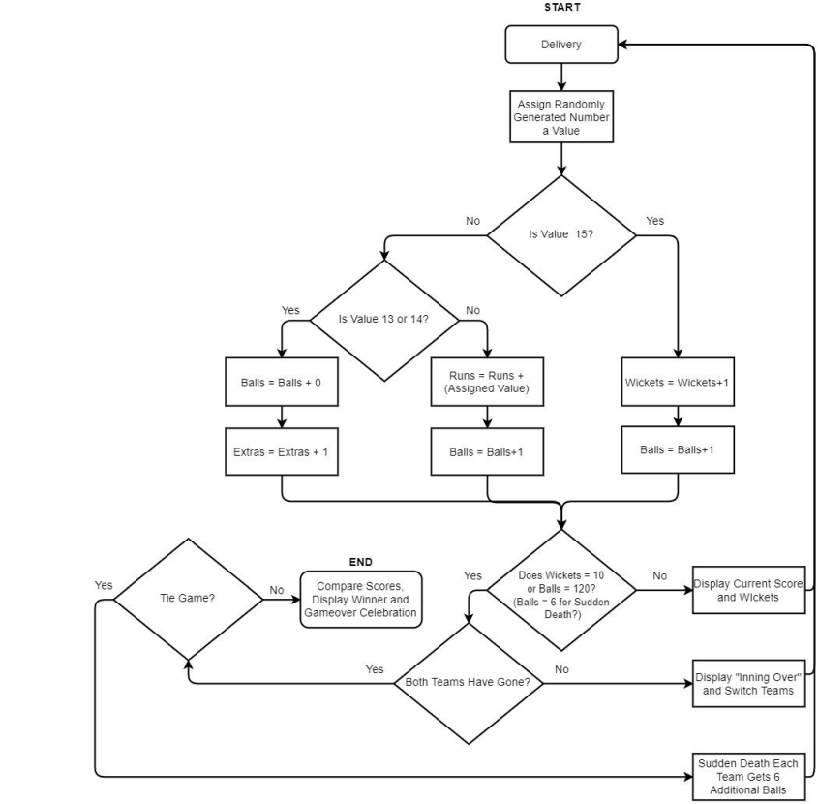

**CODE: # CRICKET SCORE CARD**

#include<stdio.h>

#include<stdlib.h>

struct batsman

{

char name[25];

int runs,score,balls,toruns,tobal,ones,twos,threes,fours,sixes;

int max_six,max_run,max_four;

float str;

}pl1[100],pl3;

struct bowler

{

char name[25];

int runsgv,wkttkn,overs;

int max_w;

float econ;

}pl2[100],pl4;

int main()

{

int plno,choice;

int i,n,m;

printf("Enter the Batsman detail:\n");

printf("Enter the number of batsman:\n");

scanf("%d",&m);

for(i=0;i<m;i++)

{

printf("Enter name of batsman%d:\n",i+1);

scanf("%s",pl1[i].name);

printf("Enter the number of ones scored by player%d:\n ",i+1);

scanf("%d",&pl1[i].ones);

printf("Enter the number of twos scored by player%d:\n ",i+1);

scanf("%d",&pl1[i].twos);

printf("Enter the number of threes scored by player%d:\n ",i+1);

scanf("%d",&pl1[i].threes);

printf("Enter the number of fours scored by player%d:\n ",i+1);

scanf("%d",&pl1[i].fours);

printf("Enter the number of sixes scored by player%d:\n ",i+1);

scanf("%d",&pl1[i].sixes);

printf("Enter the balls played by the player%d:\n",i+1);

scanf("%d",&pl1[i].balls);

}

printf("\nEnter the bowlers details:\n");

printf("Enter the number of bowlers:\n");

scanf("%d",&n);

for(i=0;i<n;i++)

{

printf("\nEnter name of bowler%d:",i+1);

scanf("%s",pl2[i].name);

printf("Enter the runs given by the bowler%d:\n ",i+1);

scanf("%d",&pl2[i].runsgv);

printf("Enter the overs bowled by the bowler%d:\n",i+1);

scanf("%d",&pl2[i].overs);

printf("Enter the wickets taken by the bowler%d\n",i+1);

scanf("%d",&pl2[i].wkttkn);

}

printf("Thank you all details are recorded\n");

do

{

printf("Enter the choice:\n 1)Batsman detail:\n 2)Bowlers detail:\n 3)Match summary:\n 4)Record:\n 5)Exit\n ");

scanf("%d",&choice);

switch(choice)

{

case 1:

printf("Enter the batsman number to see his details\n");

scanf("%d",&plno);

plno--;

printf(" Player Detail\n");

printf("===========================================================================\n");

printf(" Batsman runs balls fours sixes sr \n");

printf("===========================================================================\n");

pl1[plno].runs=(1*pl1[plno].ones)+(2*pl1[plno].twos)+(3*pl1[plno].threes)+(4*pl1[plno].fours)+(6*pl1[plno].sixes);

pl1[plno].str=(pl1[plno].runs*100.00)/pl1[plno].balls;

printf(" %-15s %-14d %-13d %-11d %-11d %-9.2f\n\n",pl1[plno].name,pl1[plno].runs,pl1[plno].balls,pl1[plno].fours,pl1[plno].sixes,pl1[plno].str);

break;

case 2:

printf("Enter the bowlers number to see his details\n");

scanf("%d",&plno);

plno--;

printf(" Player Detail\n ");

printf("=================================================================\n");

printf(" Bowler overs runs wicket economy\n");

printf("=================================================================\n");

for(i=0;i<n;i++)

{ pl2[plno].econ=pl2[plno].runsgv/pl2[plno].overs;

printf(" %-15s %-14d %-13d %-11d %-11.2f\n\n",pl2[plno].name,pl2[plno].overs,pl2[plno].runsgv,pl2[plno].wkttkn,pl2[plno].econ);

}

break;

case 3:

printf(" Match summary\n");

printf("==========================================================================\n");

printf(" Batsman runs balls fours sixes sr \n");

printf("==========================================================================\n");

for(i=0;i<1;i++)

{

pl1[i].runs=(1*pl1[i].ones)+(2*pl1[i].twos)+(3*pl1[i].threes)+(4*pl1[i].fours)+(6*pl1[i].sixes);

pl3.toruns+=pl1[i].runs;

pl1[i].str=(pl1[i].runs*100.00)/pl1[i].balls;

printf(" %-15s %-14d %-13d %-11d %-11d %-9.2f\n\n",pl1[i].name,pl1[i].runs,pl1[i].balls,pl1[i].fours,pl1[i].sixes,pl1[i].str);

}

printf("TOTAL RUNS:%d\n\n",pl3.toruns);

printf("\n\n");

printf("=================================================================\n");

printf(" Bowler overs runs wicket economy\n");

printf("=================================================================\n");

for(i=0;i<n;i++)

{ pl2[i].econ=pl2[i].runsgv/pl2[i].overs;

printf(" %-15s %-14d %-13d %-11d %-11.2f\n\n\n",pl2[i].name,pl2[i].overs,pl2[i].runsgv,pl2[i].wkttkn,pl2[i].econ);

}

break;

case 4: pl3.max_run=0,pl4.max_w=0,pl3.max_four=0,pl3.max_six=0;

for(i=0;i<m;i++)

{

pl1[i].runs=(1*pl1[i].ones)+(2*pl1[i].twos)+(3*pl1[i].threes)+(4*pl1[i].fours)+(6*pl1[i].sixes);

if(pl3.max_run<pl1[i].runs)

{

pl3.max_run=pl1[i].runs;

}

if(pl3.max_six<pl1[i].sixes)

{

pl3.max_six=pl1[i].sixes;

}

if(pl3.max_four<pl1[i].fours)

{

pl3.max_four=pl1[i].fours;

}

if(pl4.max_w<pl2[i].wkttkn)

{

pl4.max_w=pl2[i].wkttkn;

}

}

printf("Highest runs scored by the batsman:%d\n",pl3.max_run);

printf("Maximum fours scored by the batsman:%d\n",pl3.max_four);

printf("Maximum sixes scored by the batsman%d:\n",pl3.max_six);

printf("Maximum wickets taken by the bowler:%d\n",pl4.max_w);

break;

case 5:

exit(1);

default:

printf("Enter the correct choice\n");

break;

}

}while(choice!=5);

return 0;

}

**OUTPUT:**

Enter the Batsman detail:

Enter the number of batsman:

3

Enter name of batsman1:

rohithsharma

Enter the number of ones scored by player1:

12

Enter the number of twos scored by player1:

3

Enter the number of threes scored by player1:

5

Enter the number of fours scored by player1:

10

Enter the number of sixes scored by player1:

10

Enter the balls played by the player1:

60

Enter name of batsman2:

gill

Enter the number of ones scored by player2:

10

Enter the number of twos scored by player2:

5

Enter the number of threes scored by player2:

3

Enter the number of fours scored by player2:

10

Enter the number of sixes scored by player2:

2

Enter the balls played by the player2:

50

Enter name of batsman3:

viratkohli

Enter the number of ones scored by player3:

10

Enter the number of twos scored by player3:

10

Enter the number of threes scored by player3:

5

Enter the number of fours scored by player3:

15

Enter the number of sixes scored by player3:

20

Enter the balls played by the player3:

70

Enter the bowlers details:

Enter the number of bowlers:

3

Enter name of bowler1:siraj

Enter the runs given by the bowler1:

60

Enter the overs bowled by the bowler1:

10

Enter the wickets taken by the bowler1

1

Enter name of bowler2:harshalpatel

Enter the runs given by the bowler2:

70

Enter the overs bowled by the bowler2:

10

Enter the wickets taken by the bowler2

2

Enter name of bowler3:chahal

Enter the runs given by the bowler3:

100

Enter the overs bowled by the bowler3:

10

Enter the wickets taken by the bowler3

1

Thank you all details are recorded

Enter the choice:

1)Batsman detail:

2)Bowlers detail:

3)Match summary:

4)Record:

5)Exit

1

Enter the batsman number to see his details

3

Player Detail

===========================================================================

Batsman runs balls fours sixes sr

===========================================================================

viratkohli 225 70 15 20 321.43

Enter the choice:

1)Batsman detail:

2)Bowlers detail:

3)Match summary:

4)Record:

5)Exit

1

Enter the batsman number to see his details

1

Player Detail

===========================================================================

Batsman runs balls fours sixes sr

===========================================================================

rohithsharma 133 60 10 10 221.67

Enter the choice:

1)Batsman detail:

2)Bowlers detail:

3)Match summary:

4)Record:

5)Exit

1

Enter the batsman number to see his details

2

Player Detail

===========================================================================

Batsman runs balls fours sixes sr

===========================================================================

gill 81 50 10 2 162.00

Enter the choice:

1)Batsman detail:

2)Bowlers detail:

3)Match summary:

4)Record:

5)Exit

2

Enter the bowlers number to see his details

1

Player Detail

=================================================================

Bowler overs runs wicket economy

=================================================================

siraj 10 60 1 6.00

siraj 10 60 1 6.00

siraj 10 60 1 6.00

Enter the choice:

1)Batsman detail:

2)Bowlers detail:

3)Match summary:

4)Record:

5)Exit

2

Enter the bowlers number to see his details

2

Player Detail

=================================================================

Bowler overs runs wicket economy

=================================================================

harshalpatel 10 70 2 7.00

harshalpatel 10 70 2 7.00

harshalpatel 10 70 2 7.00

Enter the choice:

1)Batsman detail:

2)Bowlers detail:

3)Match summary:

4)Record:

5)Exit

2

Enter the bowlers number to see his details

3

Player Detail

=================================================================

Bowler overs runs wicket economy

=================================================================

chahal 10 100 1 10.00

chahal 10 100 1 10.00

chahal 10 100 1 10.00

Enter the choice:

1)Batsman detail:

2)Bowlers detail:

3)Match summary:

4)Record:

5)Exit

3

Match summary

==========================================================================

Batsman runs balls fours sixes sr

==========================================================================

rohithsharma 133 60 10 10 221.67

TOTAL RUNS:133

=================================================================

Bowler overs runs wicket economy

=================================================================

siraj 10 60 1 6.00

harshalpatel 10 70 2 7.00

chahal 10 100 1 10.00

Enter the choice:

1)Batsman detail:

2)Bowlers detail:

3)Match summary:

4)Record:

5)Exit

4

Highest runs scored by the batsman:225

Maximum fours scored by the batsman:15

Maximum sixes scored by the batsman20:

Maximum wickets taken by the bowler:2

Enter the choice:

1)Batsman detail:

2)Bowlers detail:

3)Match summary:

4)Record:

5)Exit